Task 7: Critical Evaluation of Principal Component Analysis

7.1 Is Dimensionality Reduction Necessary Here?
This is the right question to ask before running PCA, and the honest answer for this dataset is: only marginally, and with real trade-offs. Our predictor set (age, sex, plus 5–6 lab indices) is small by the standards that typically motivate PCA. The literature is clear that PCA's core value proposition is for genuinely high-dimensional data - datasets with dozens, hundreds, or thousands of correlated features, such as blood microRNA panels used for disease diagnosis or robotic-assessment batteries generating 100+ metrics per participant. Our situation - 6 clinical variables - sits at the opposite end of that spectrum from where PCA is normally indispensable.
That said, dimensionality reduction is not the only reason to consider PCA. Task 3 and Task 5 independently established a real, measured multicollinearity problem among these 6 variables (correlation up to r=0.96 between HB and PCV; VIF up to 461 for MCV in the logistic regression). This is the more relevant justification for PCA here: not reducing the number of variables for its own sake, but removing correlation structure - a distinct motivation, more precisely called Principal Components Regression (PCR) when the resulting components are then used in a downstream model and understood in the statistical literature as closely related to ridge regression in how it addresses collinearity.

7.2 What PCA Actually Found in Our Data
Running PCA (correlation-based, i.e. standardized variables, since HB/MCH/MCHC/MCV/PCV/RBC are on entirely different scales - g/dL, pg, %, fL, ×10¹²/L):
Component | Eigenvalue | % Variance | Cumulative %
PC1 | 2.92 | 48.7% | 48.7%
PC2 | 2.05 | 34.2% | 82.8%
PC3 | 1.02 | 17.0% | 99.8%
PC4 | 0.007 | 0.1% | 100.0%
PC5 | 0.002 | ~0% | 100.0%
PC6 | 0.001 | ~0% | 100.0%
Applying the conventional Kaiser criterion (retain components with eigenvalue > 1), 3 of the 6 components should be retained - not the "2 components for a nice 2D plot" outcome PCA is often informally expected to produce. PC1+PC2 alone capture 82.8% of the variance - respectable, but short of the commonly used 90% retention threshold, meaning a 2-component reduction would discard a non-trivial 17.2% of the variance.
Interpreting PC1 and PC2:
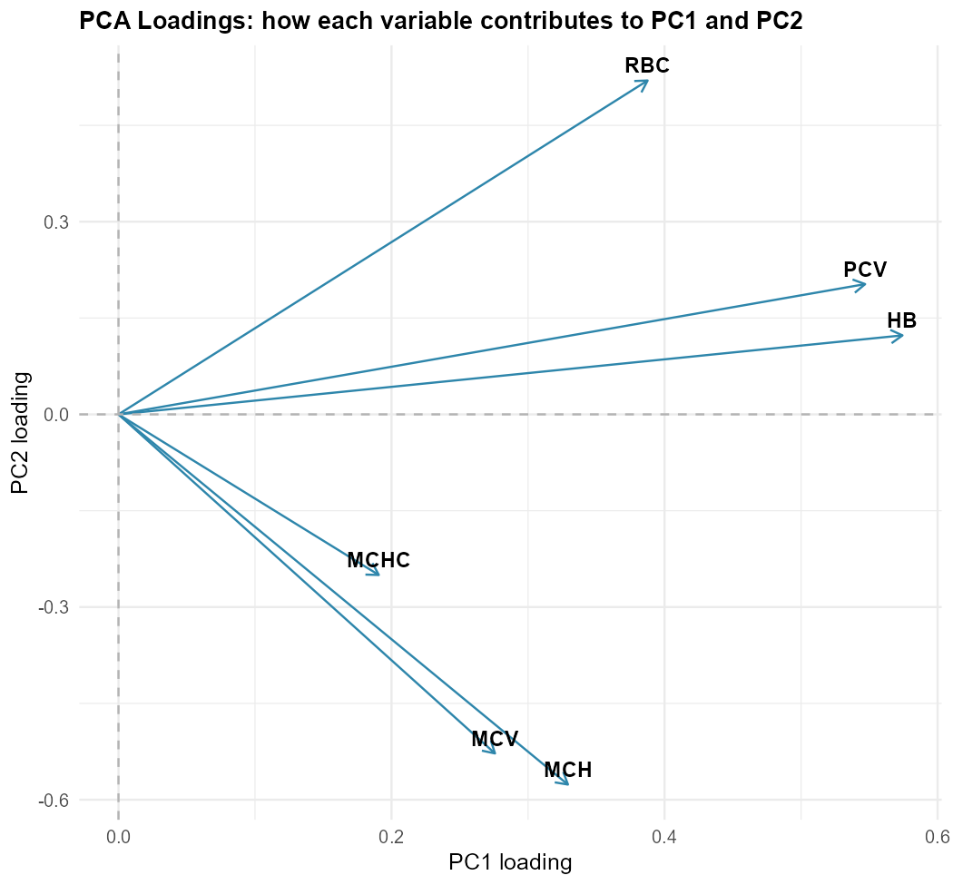
- PC1 is dominated by HB (0.574), PCV (0.547), and RBC (0.388) - a "red cell mass/quantity" axis.
- PC2 is dominated by MCH (−0.576), MCV (−0.528), and RBC (0.520) - roughly a "red cell size/content" axis, cleanly separated from PC1 in the loadings plot.
This is a genuinely interpretable result - the two clusters correspond to recognizable clinical concepts (how much red cell mass a patient has vs. what size/hemoglobin-content their individual cells are) - a more favorable outcome than PCA often produces. This aligns with the broader literature's caveat that PCA's components are linear combinations of all input variables and therefore often lack clear meaning, especially as the number of inputs grows; our small, clinically related variable set is a comparatively favorable case for interpretability precisely because it starts from only 6 well-understood inputs, not because PCA is inherently transparent.

7.3 Possible Advantages (Tested, Not Assumed)
- Multicollinearity is fully resolved by construction. The post-PCA correlation matrix among PC1-PC6 is the identity matrix (all off-diagonal correlations exactly 0) - PCA's defining mathematical property. This directly solves the VIF problem documented in Task 5.
- Some genuine noise reduction. PC4–PC6 jointly explain only 0.14% of total variance, suggesting these dimensions are close to pure noise (or extremely fine-grained measurement variation) that could reasonably be discarded without meaningful information loss.
- A clinically interpretable structure emerged (red cell mass vs. red cell size/content), which is a genuine advantage for communicating findings to a non-technical audience, consistent with applications like PCA-based "aging clocks" from clinical biomarker panels, where the technique successfully identified interpretable signatures of metabolic, cardiac, and renal dysfunction from routine clinical data.

7.4 Limitations (What We Actually Measured)
Two-component reduction measurably hurt predictive performance. We compared three logistic regression specifications on the same held-out test set:

Model | Predictors | AIC | Test Accuracy | Test AUC
Original variables | age, sex, MCH, MCHC, MCV, PCV, RBC (7) | 6,754.0 | 92.45% | 0.983
First 2 PCs only | age, sex, PC1, PC2 (4) | 7,402.2 | 91.88% | 0.979
All 6 PCs | age, sex, PC1–PC6 (8) | 6,633.5 | 92.59% | 0.982
This is the central finding of this task, and it cuts against a naive "PCA always helps" narrative. Reducing to 2 PCs increased AIC by nearly 650 points and reduced both accuracy and AUC relative to the original variables - a real, measured cost of discarding PC3, not a hypothetical concern. Using all 6 PCs performs essentially identically to (marginally better AIC than) the original variables, which makes sense mathematically: PCA is an orthogonal rotation of the same information when no components are dropped, so no genuine information is gained or lost - only the coefficient interpretation changes. This means PCA offered no true dimensionality reduction benefit for this dataset once enough components are retained to preserve accuracy; the only way to get a smaller model is to accept the accuracy cost of discarding PC3.
This is consistent with the wider literature's core caution: dimensionality reduction is a trade-off between compression and information loss, and that trade-off does not automatically favor compression - here, the trade-off was unfavorable at the "2 components" level our small variable set would suggest is the default option.
Interpretability is genuinely reduced for the model itself, even though the loadings happened to be interpretable in isolation. A coefficient on "PC1" in a regression is a coefficient on "a mix of 57% HB + 55% PCV + 39% RBC (standardized)", not on a single clinically actionable measurement a clinician can read directly off a lab report - the literature's general warning that PCA can create a "black box" for downstream regression applies here, even in this comparatively favorable, low-dimensional case.

7.5 Expected Impact on Predictive Modelling
Based on our own comparison above, there are three concrete conclusions for this project's modelling work:
- PCA is not a beneficial pre-processing step for our final predictive model. Model 3 from Task 5 (logistic regression with the original variables and an age×sex interaction) already achieved 94.4% accuracy - PCA offers no path to a materially better result, only a path to a worse one (if compressed to fewer components) or an equivalent one with less interpretable coefficients (if all components are retained).
- Task 5's actual solution to multicollinearity - LASSO/Elastic Net regularization - was the better choice for this problem, precisely because it preserves variable-level interpretability (a coefficient on MCV is still readable as "MCV") while addressing the same underlying collinearity issue, at a small accuracy cost comparable to PCA's own trade-off.
- PCA's real value in this project is diagnostic and pedagogical, not a production modelling step: it independently confirms the two clusters of collinear variables that VIF flagged (PC1: HB/PCV/RBC - the same trio VIF found most inflated after accounting for MCV/MCH; PC2: MCH/MCV - again matching the r=0.88 pair flagged in Task 3), giving the client an additional, visually intuitive way to understand why their red-cell panel is redundant, even though we do not recommend deploying PCA-transformed variables in the operational model.

7.6 When PCA Should - and Should Not - Be Used
PCA should be used when:
- The number of correlated input variables is genuinely large (tens to thousands), such as genomic, microRNA, or high-frequency sensor/robotic assessment data, where manual inspection of a correlation matrix is no longer feasible.
- The analytic goal is visualization or exploratory clustering (e.g., "do anemic and non-anemic patients separate in reduced space?") rather than optimizing a specific predictive model's accuracy.
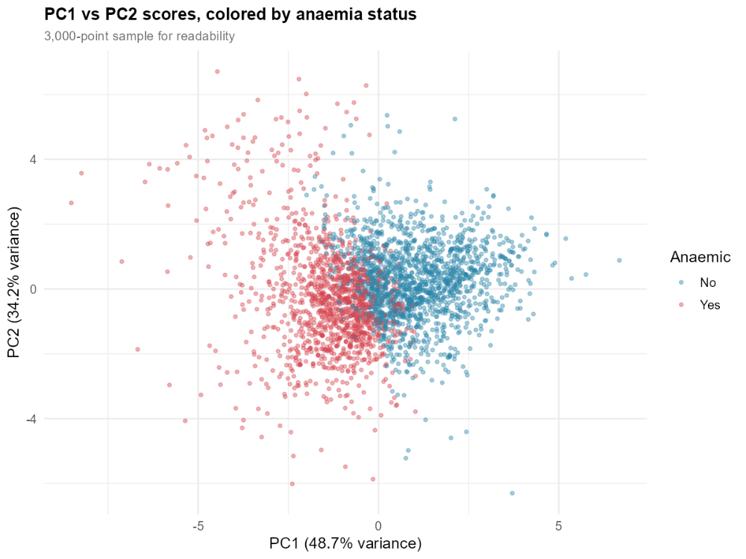
our PC1-vs-PC2 scatter plot served exactly this exploratory purpose well, showing partial but incomplete separation by anemia status.
- Downstream algorithms are sensitive to collinearity in ways regularization cannot easily fix (e.g., certain clustering or distance-based methods), or where the modelling goal is genuinely about capturing latent structure (e.g., disease sub-typing) rather than prediction from named clinical variables.
- A rough noise-reduction step is wanted before an algorithm that would otherwise overfit high-dimensional, highly correlated inputs - relevant for genomics-scale data, less so for our 6-variable panel.
PCA should not be used, or should be used cautiously, when:
- The number of original variables is already small and individually clinically meaningful — exactly our situation, where a clinician wants to read "HB = 9.2, MCV = 76" directly, not a PC score.
- The applied cost of interpretability loss is high - in a healthcare consultancy context, being able to explain which specific lab value is driving a risk flag matter for clinical trust and actionability.
- Regularization methods (Ridge/LASSO/Elastic Net) are available and achieve comparable collinearity control while preserving variable-level meaning - as they did here.
- As our own comparison showed, reducing to fewer components than needed to preserve the data's effective rank (here, 3 components, not 2) can measurably harm predictive performance - a risk that is easy to underestimate if PCA is applied by default without checking, as we did here, whether the reduced representation still performs adequately.

7.7 Conclusion and Recommendation
For this specific dataset and project, we recommend against using PCA as a pre-processing step for the operational screening model and recommend continuing with the Elastic Net approach established in Task 5. PCA's collinearity-resolving property is real and mathematically guaranteed, but our own comparison shows it does not translate into a practical advantage here: the interpretability cost is real, the accuracy cost is real if compressed to the "obvious" 2-component solution, and the alternative already in use (regularized logistic regression) solves the same underlying problem while keeping the model's language aligned with how clinicians already read an FBC report.
We do, however, recommend retaining the PCA analysis itself as a diagnostic and communication tool - the loadings plot is an effective, intuitive way to show the client's team why their red-cell panel contains redundant information, independent of whether PCA-transformed scores are ever used in a live model.

Sources referenced in this section
- Principal component analysis of blood microRNA datasets facilitates diagnosis of diverse diseases. PLOS One. https://journals.plos.org/plosone/article?id=10.1371%2Fjournal.pone.0234185
- Multi-omic enriched blood-derived digital signatures reveal mechanistic and confounding disease clusters for differential diagnosis. PubMed. https://pubmed.ncbi.nlm.nih.gov/42591264/
- Principal component-based clinical aging clocks identify signatures of healthy aging and targets for clinical intervention. PMC. https://www.ncbi.nlm.nih.gov/pmc/articles/PMC11333290/
- Outcome Prediction Models for Critically Ill Patients Using Small Routine Laboratory Datasets. medRxiv. https://www.medrxiv.org/content/10.64898/2026.04.26.26351758.full.pdf
- Using principal component analysis to reduce complex datasets produced by robotic technology in healthy participants. Journal of NeuroEngineering and Rehabilitation. https://jneuroengrehab.biomedcentral.com/articles/10.1186/s12984-018-0416-5
- A Guide to Principal Component Analysis (PCA) for Machine Learning. Keboola. https://www.keboola.com/blog/pca-machine-learning
- Principal component gene set enrichment (PCGSE). PMC. https://www.ncbi.nlm.nih.gov/pmc/articles/PMC4543476/
- Principal Components Regression (on collinearity and PC selection in regression). NSF PAR. https://par.nsf.gov/servlets/purl/10181908

